Name: Will

Date: 2021/06/06

Project: Project4

Description:

All work comes from Will.

Exercise 1

Code

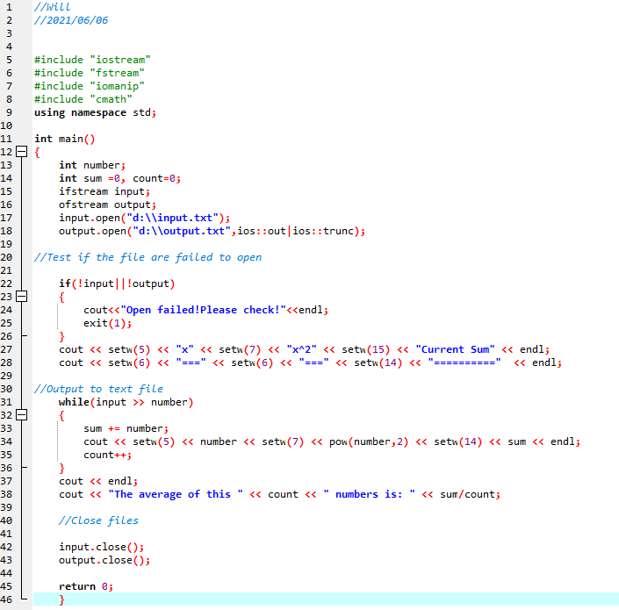

Output

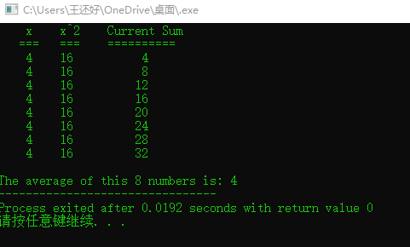

Exercise 2

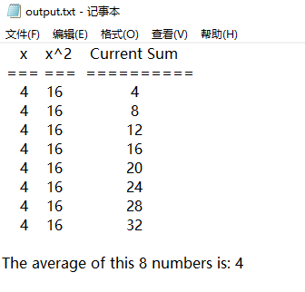

Exercise 3

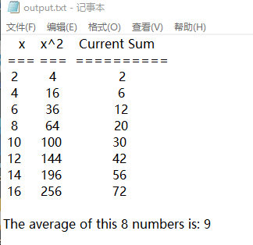

Code

//Will

//2021/06/06

//cs002

#include "iostream"

#include "fstream"

#include "iomanip"

#include "io.h"

#include "direct.h"

#include "cmath"

using namespace std;

//Input from text

int main()

{

int number;

int sum = 0, count = 0;

ifstream input;

ofstream output;

//Test if the file are failed to open

output.open("d:\\input.txt", ios::out | ios::trunc);

output << "2 4 6 8 10 12 14 16" << endl;

output.close();

input.open("d:\\input.txt");

output.open("d:\\output.txt", ios::out | ios::trunc);

//Test if the file are failed to open and output to text file

if (!input || !output)

{

cout << "Open failed!Please check!" << endl;

exit(1);

}

output << setw(5) << "x" << setw(7) << "x^2" << setw(15) << "Current Sum" << endl;

output << setw(4) << "===" << setw(4) << "===" << setw(12) << "==========" << endl;

while (input >> number)

{

sum += number;

output << setw(3) << number << setw(6) << pow(number, 2) << setw(16) << sum << endl;

count++;

}

output << endl;

output << "The average of this " << count << " numbers is: " << sum / count;

//Close files

input.close();

output.close();

return 0;

}